Supplementary Figure 1. Preliminary data demonstrating the correlation of perfusate ALT and AST levels and peak serum transaminases (A, B)
Not analyzed n=4. Abbreviations used: ALT, alanine aminotransferase; AST, aspartate aminotransferase; IU, international unit
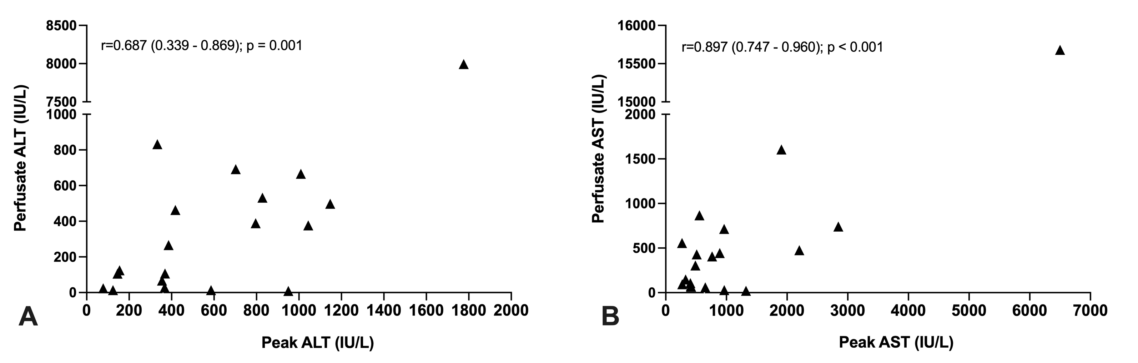

Supplementary Figure 2. Kaplan-Meier curves of graft- and patient survival after one year (A, B)
Patients who are yet to complete 1-year follow up were censored at the last study visit after 6░months (n=4). Abbreviations used: SCS, static cold storage; HOPE, hypothermic oxygenated machine perfusion, LT, liver transplantation
